Dear University of Akron Traveler,

We are pleased to announce our partnership with Christopherson Business Travel, a premier travel management company. This quick guide will answer what you need to know during the transition and managing future travel through Christopherson!

Welcome to AirPortal®
Christopherson offers travelers exclusive access to their leading travel management platform, AirPortal®. With AirPortal® you can book travel, manage itineraries, view travel alerts, and so much more, all in one place!

Getting Started with Christopherson
Travel profiles have been imported with your existing information. AirPortal provides access to your travel profile for updates or additions to your information. You will receive a welcome email to create your AirPortal password and login instructions.

Manage Travel | Travel Profile | My Travel Dashboard
Seamless integration of airline, hotel, and rental itineraries with 24/7/365 access to support teams. | Save all your travel memberships, preferences, and passport information for seamless booking. | Customizable dashboard for quick access to the travel information you need to know.
AirPortal® My Travel Dashboard
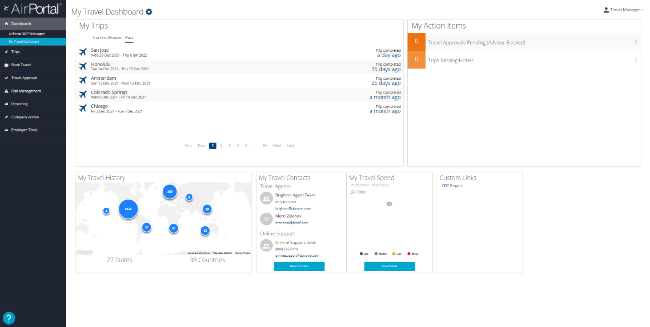
My Action Items
Stay on top of travel approvals, trips missing hotels, travel alerts, etc.
My Trips
Access your current, future, and past itineraries in one place with one click.
Customizable Widgets
Add, remove, and organize the reporting tiles for a homepage that puts the information you want to know right at your fingertips.
Want to learn more? Click here for a full video tutorial of AirPortal®.

Your Christopherson Contacts:
- University Agent Team – 800-285-3603 university.travel@cbtravel.com
- Online Navigational Support – 888-535-0179 onlinesupport@cbtravel.com
- Pam Rex, Account Management – 303-689-7706 pam.rex@cbtravel.com

